64x50

Repeated encoding.
Difficulty: Easy
Ben Poulton
Securi-Tay CTF 2026

Solution
3200 contains a base64 encoded string. This decodes to a base64 encoded string. This decodes to a base64 encoded string. Ad infinitum.
The repeated encoding actually only occurs 50 times, (mainly due to processing limits with Cyberchef and my laptop), so decoding is a simple matter of either writing a small program or just using Cyberchef
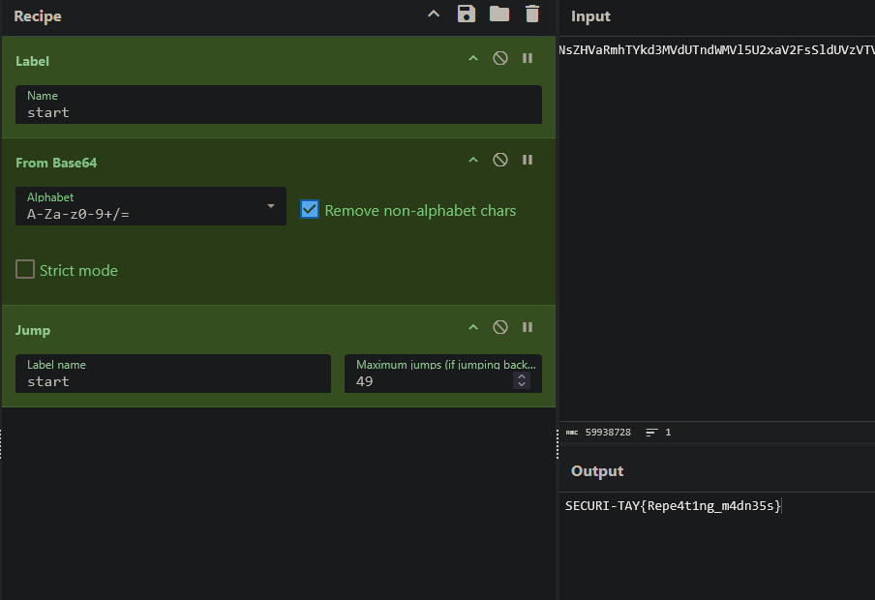
flag is SECURI-TAY{Repe4t1ng_m4dn35s}

